

**School of Engineering & Technology**

**Asian Institute of Technology**

**AT82.02 - Data Modeling and Management**



**Date: 26th August 2022**

**Lab Report: 3**

**Submitted To Submitted By:**

**Dr. Chutiporn Anutariya <Todsavad Tangtortan> [st123012]**

# Lab03: SQL (Part II)

**Objective:** To study and practice the SQL commands for data query and retrieval (SQL DML)

**Estimated Time:** 3 hours

**Number of Tasks: 13**

**Due:** Thursday 1st September 2021, 11:00 P.M.

**Description: Simple Social Network System (SNS)**

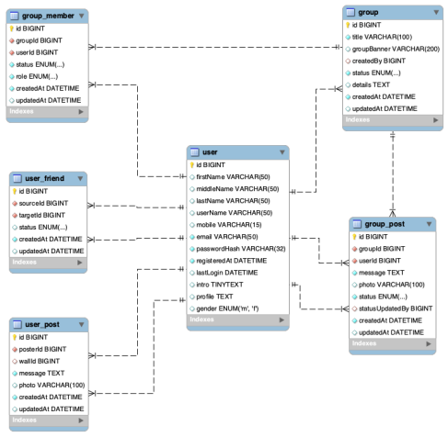

In this take-home exercise, we still follow the previous case study, the simple social network system. The exercise given in this laboratory will be based on 6 tables shown in the above ER Diagram: *user, user_friend, user_post, group, group_member and group_post***. You are required to show SQL commands and snapshots of the output** for querying to correspond to the given questions and requirements.

## Task1:

Show all public posts including posterId, message and created date from the latest to the oldest.

[SQL command and Snapshot]

SELECT posterId, message,createdAt

FROM sns.user_post

ORDER BY createdAt DESC ;

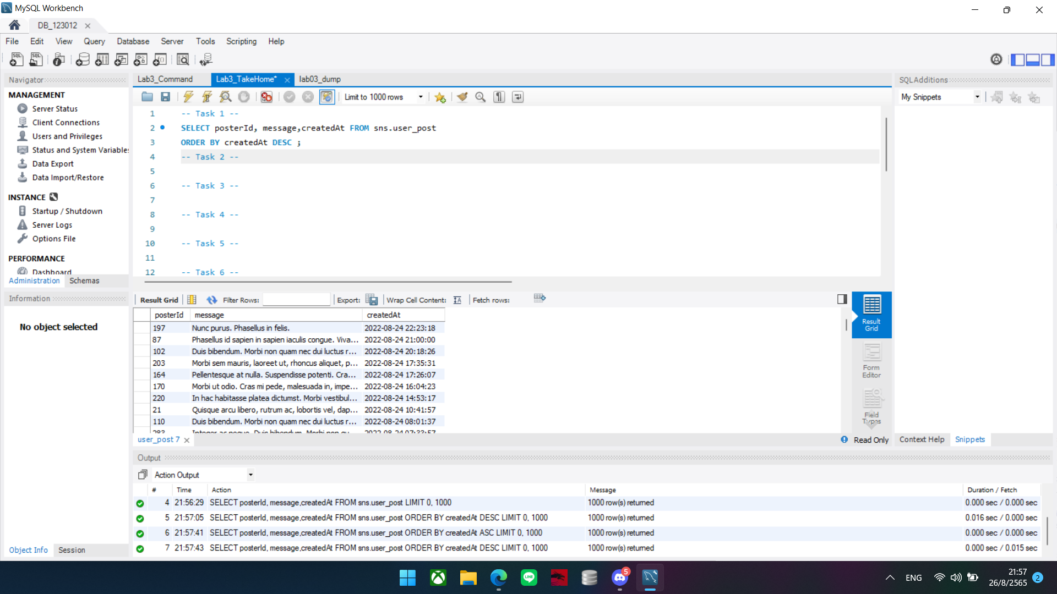

## Task 2:

List all users who didn’t have their middleName ordered by their lastName ascendingly.

[SQL command and Snapshot]

SELECT id, firstName, middleName, lastName FROM sns.user

WHERE middleName IS NULL

ORDER BY lastName ASC ;

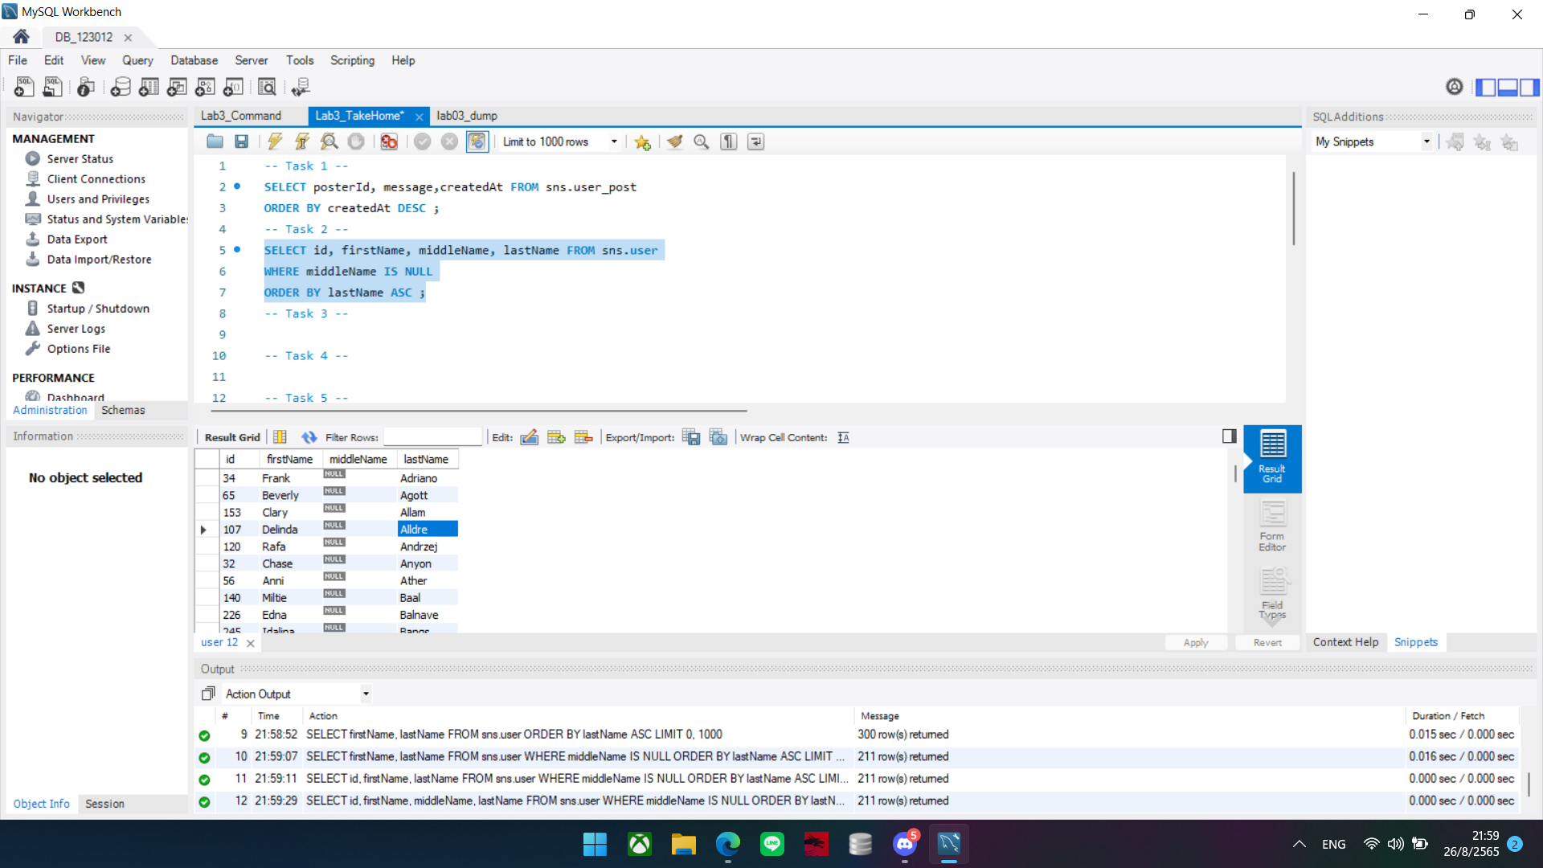

## Task 3:

List all users who recently registered to the system not later than two weeks ago (14 days from now).

[SQL command and Snapshot]

SELECT id, firstName, LastName, gender,registeredAt

FROM sns.user

WHERE registeredAt BETWEEN '2022-08-14' AND '2022-08-26'

ORDER BY registeredAt;

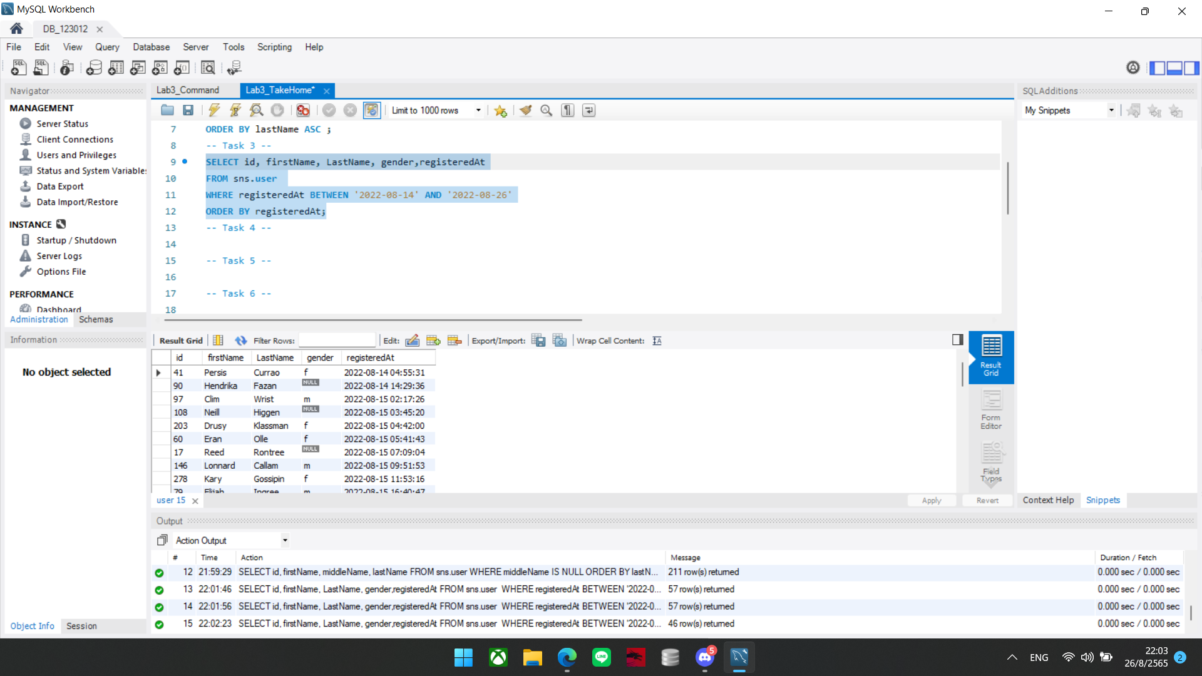

## Task 4:

The owner of the wall id ‘01’ wants to view all the posts posted on their wall before ‘2021-08-01’ where the latest posts are returned at the top. Write a SQL command for this.

[SQL command and Snapshot]

SELECT *

FROM sns.user

WHERE registeredAt < '2021-08-01'

ORDER BY registeredAt DESC;

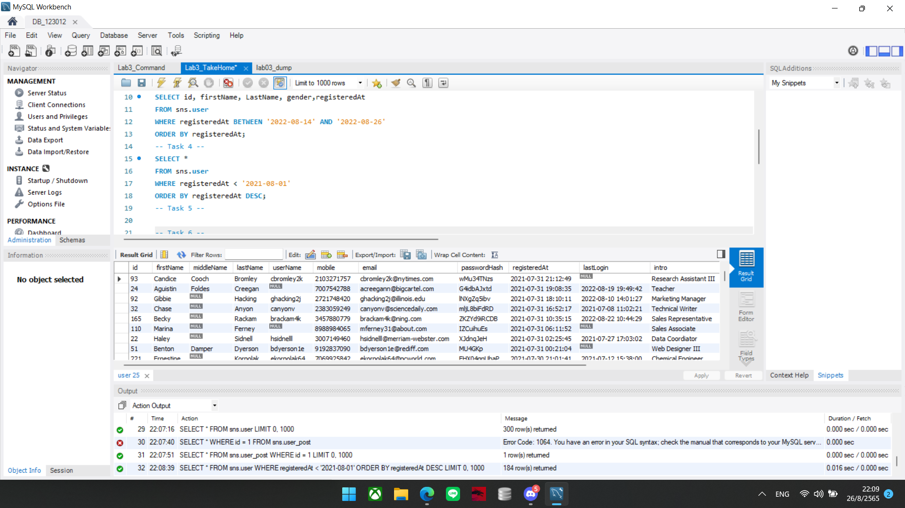

## Task 5:

If we would like to know who rejected the friend request of each user and when was he/she rejected, what is the SQL command to support this task? (hint: you can filter particular user e.g. *sourceId = 66*)

[SQL command and Snapshot]

SELECT *

FROM sns.user_friend

WHERE status = 'rejected' and sourceId = 66;

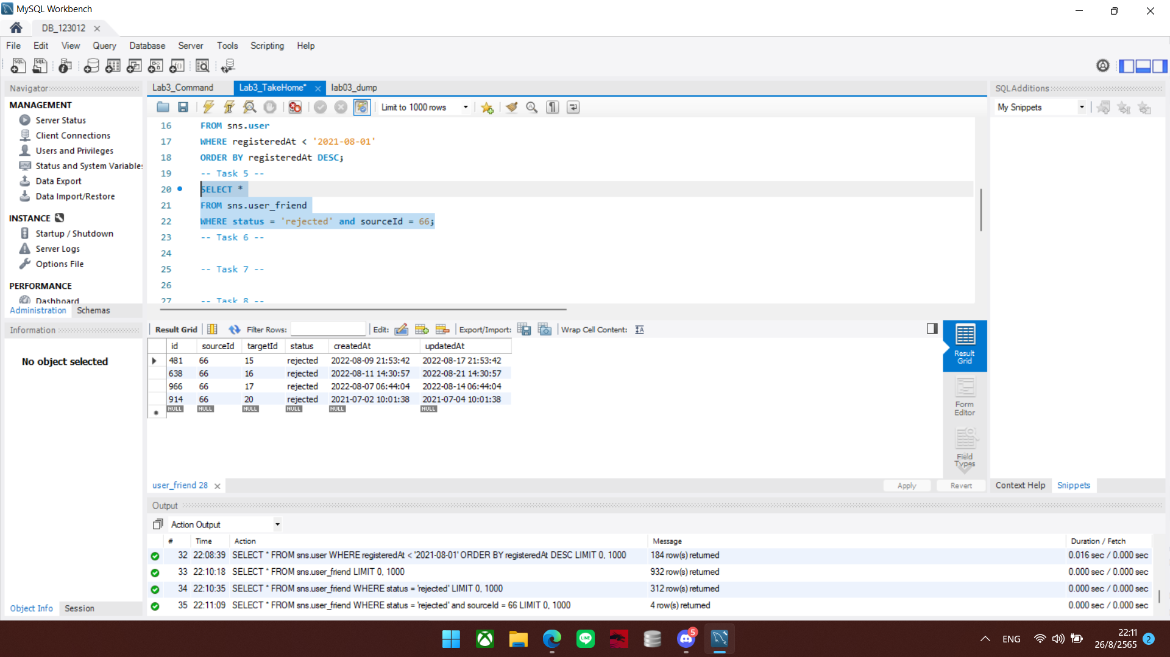

## Task 6:

How many friends does each user have (use the count of accepted friend requests)? The output should show each userId and the number of friends each user has from the highest to the lowest.

[SQL command and Snapshot]

SELECT sourceId ,status, COUNT(*) AS NoOfFriend

FROM sns.user_friend

WHERE status = 'accepted'

GROUP BY sourceId

ORDER BY NoOfFriend DESC;

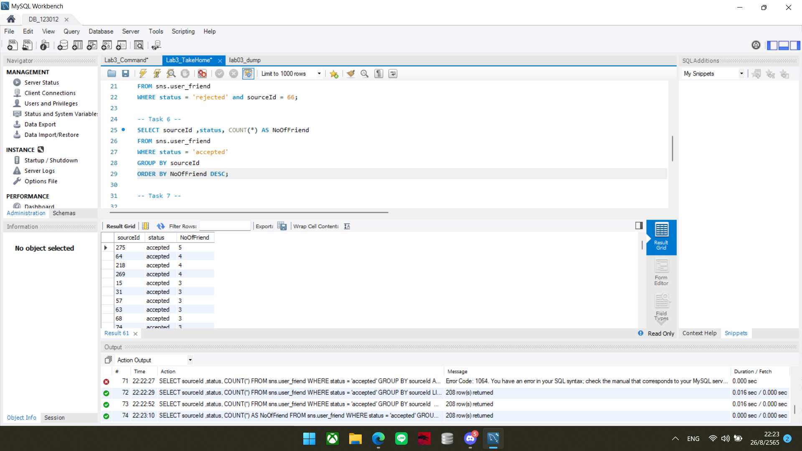

## Task 7:

Who is the latest friend of a particular user (e.g. id = 32)? Show the id of that latest friend and display how long have they been friends. (Hint: use **TIMESTAMPDIFF** to count days, **ORDER BY** updatedAt and **LIMIT** the output to only one row)

[SQL command and Snapshot]

SELECT id, COUNT(timestampdiff(DAY, createdAt, now()))

AS CountDAY, updatedAt

FROM sns.user_friend

GROUP BY id

ORDER BY updatedAt DESC LIMIT 1;

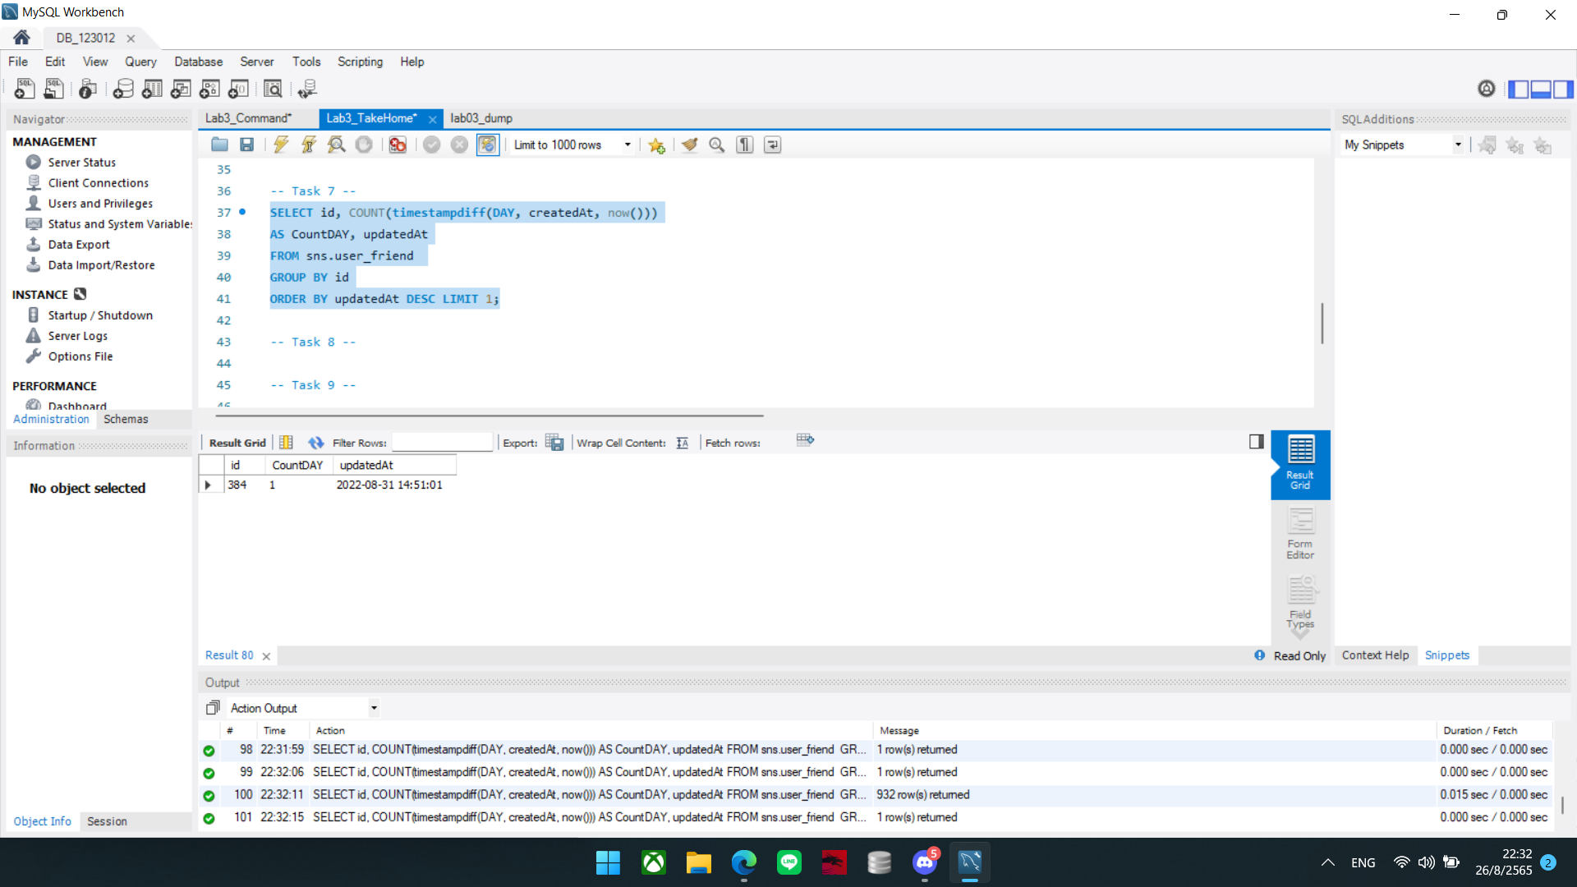

## Task 8:

Show all created groups that are not blocked (both newly created and active), showing the latest updated group first.

[SQL command and Snapshot]

SELECT *

FROM sns.group

WHERE status != 'blocked'

ORDER BY updatedAt DESC;

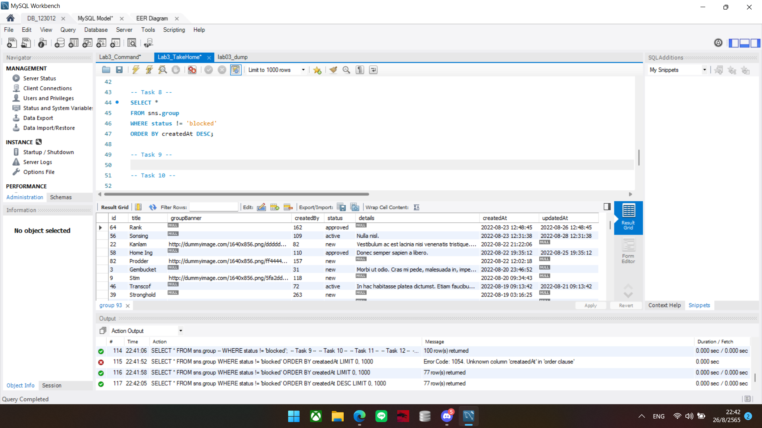

## 

## Task 9:

Show how many members of each group. List all groups sorted by the number of members from the lowest to the highest. *(A member is considered to be in the group only if their request has been approved.)*

[SQL command and Snapshot]

SELECT groupID, status, COUNT(*) AS NoOfMember

FROM sns.group_member

WHERE status = 'approved'

GROUP BY groupId

ORDER BY NoOfMember ASC;

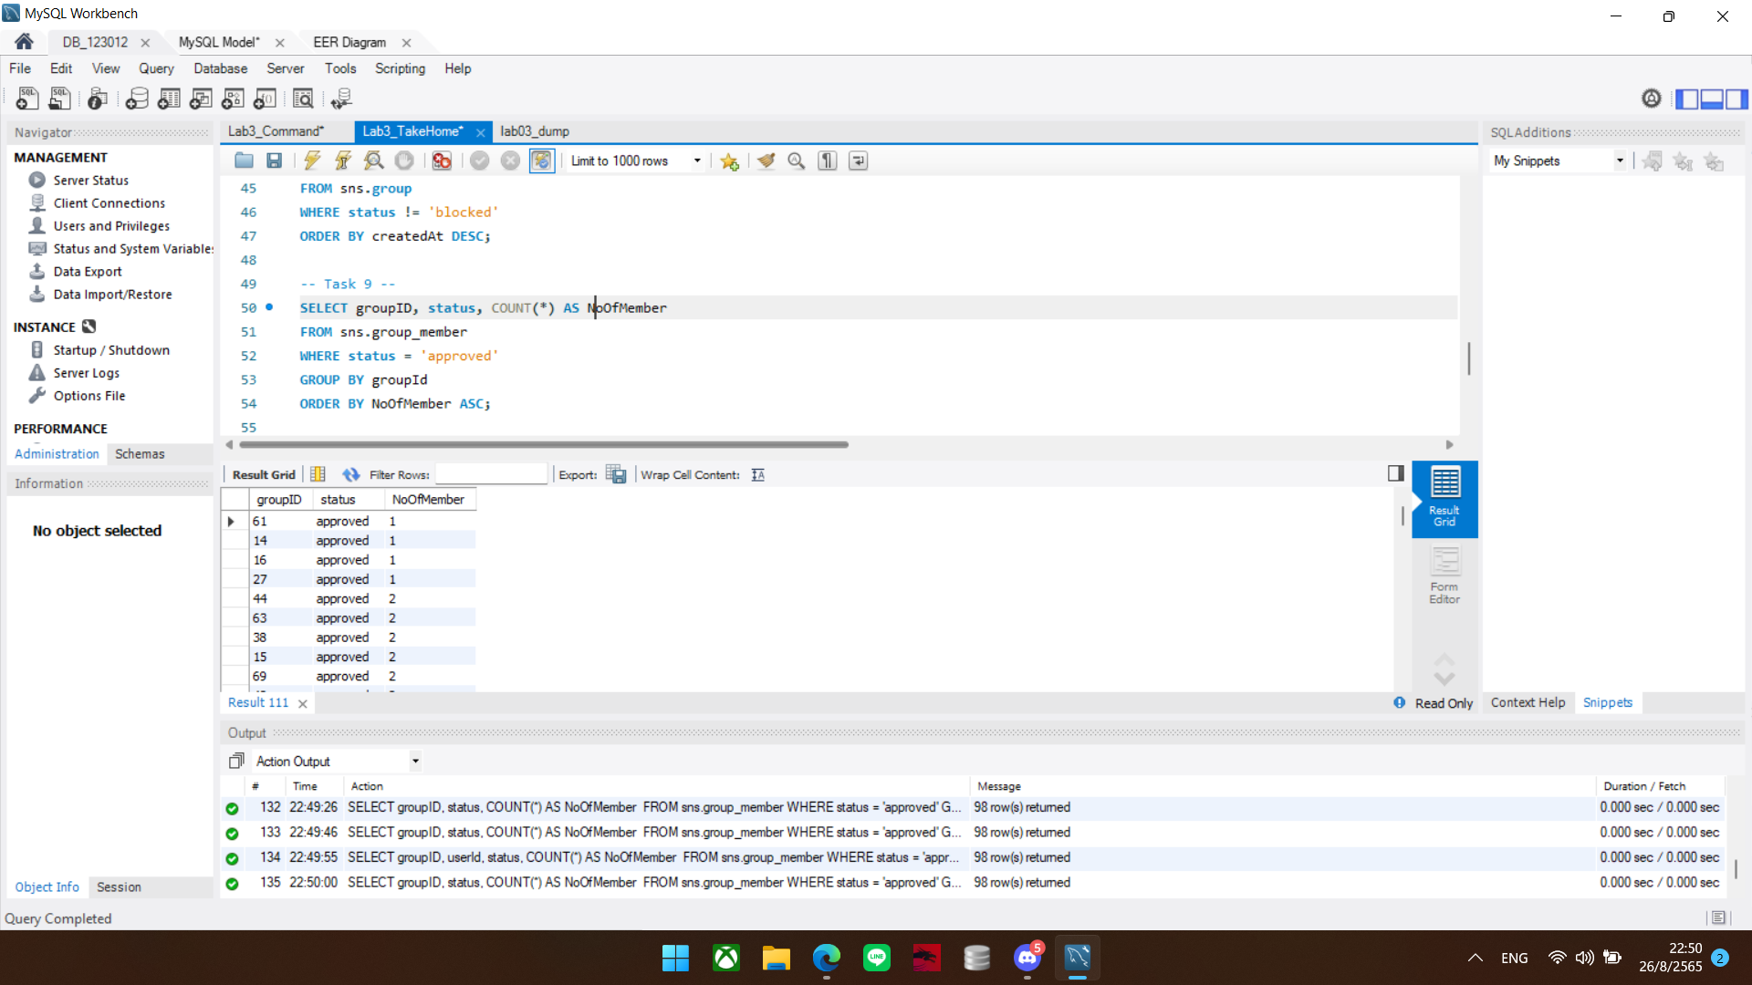

## Task 10:

Modify the above command to list the groups with their corresponding number of administrators (**highest at the top**)

[SQL command and Snapshot]

SELECT groupID, status, COUNT(*) AS NoOfMember

FROM sns.group_member

WHERE status = 'approved'

GROUP BY groupId

ORDER BY NoOfMember DESC;

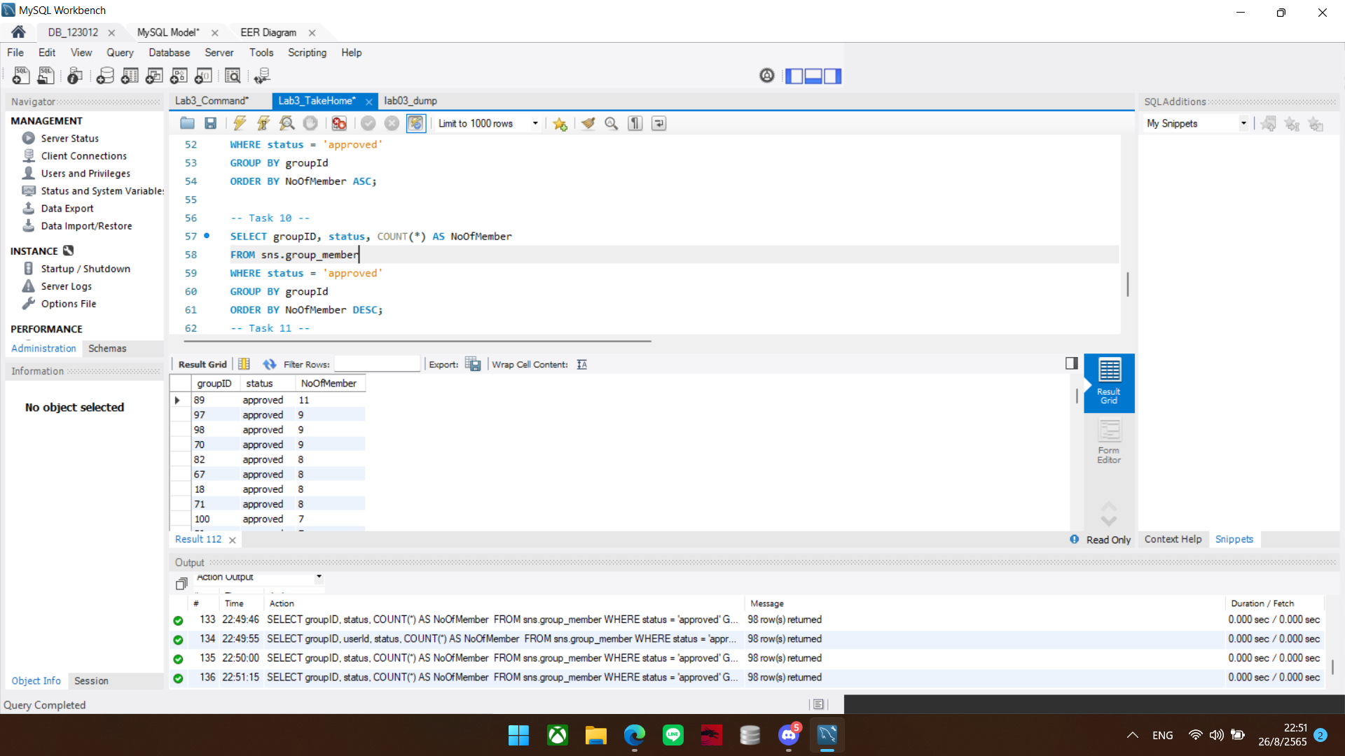

## Task 11:

List top 10 users who have joined the most number of groups with their group count and user Id.

[SQL command and Snapshot]

SELECT groupID, status, COUNT(*) AS NoOfGroup

FROM sns.group_member

WHERE status = 'approved'

GROUP BY groupId

ORDER BY NoOfGroup DESC LIMIT 10;

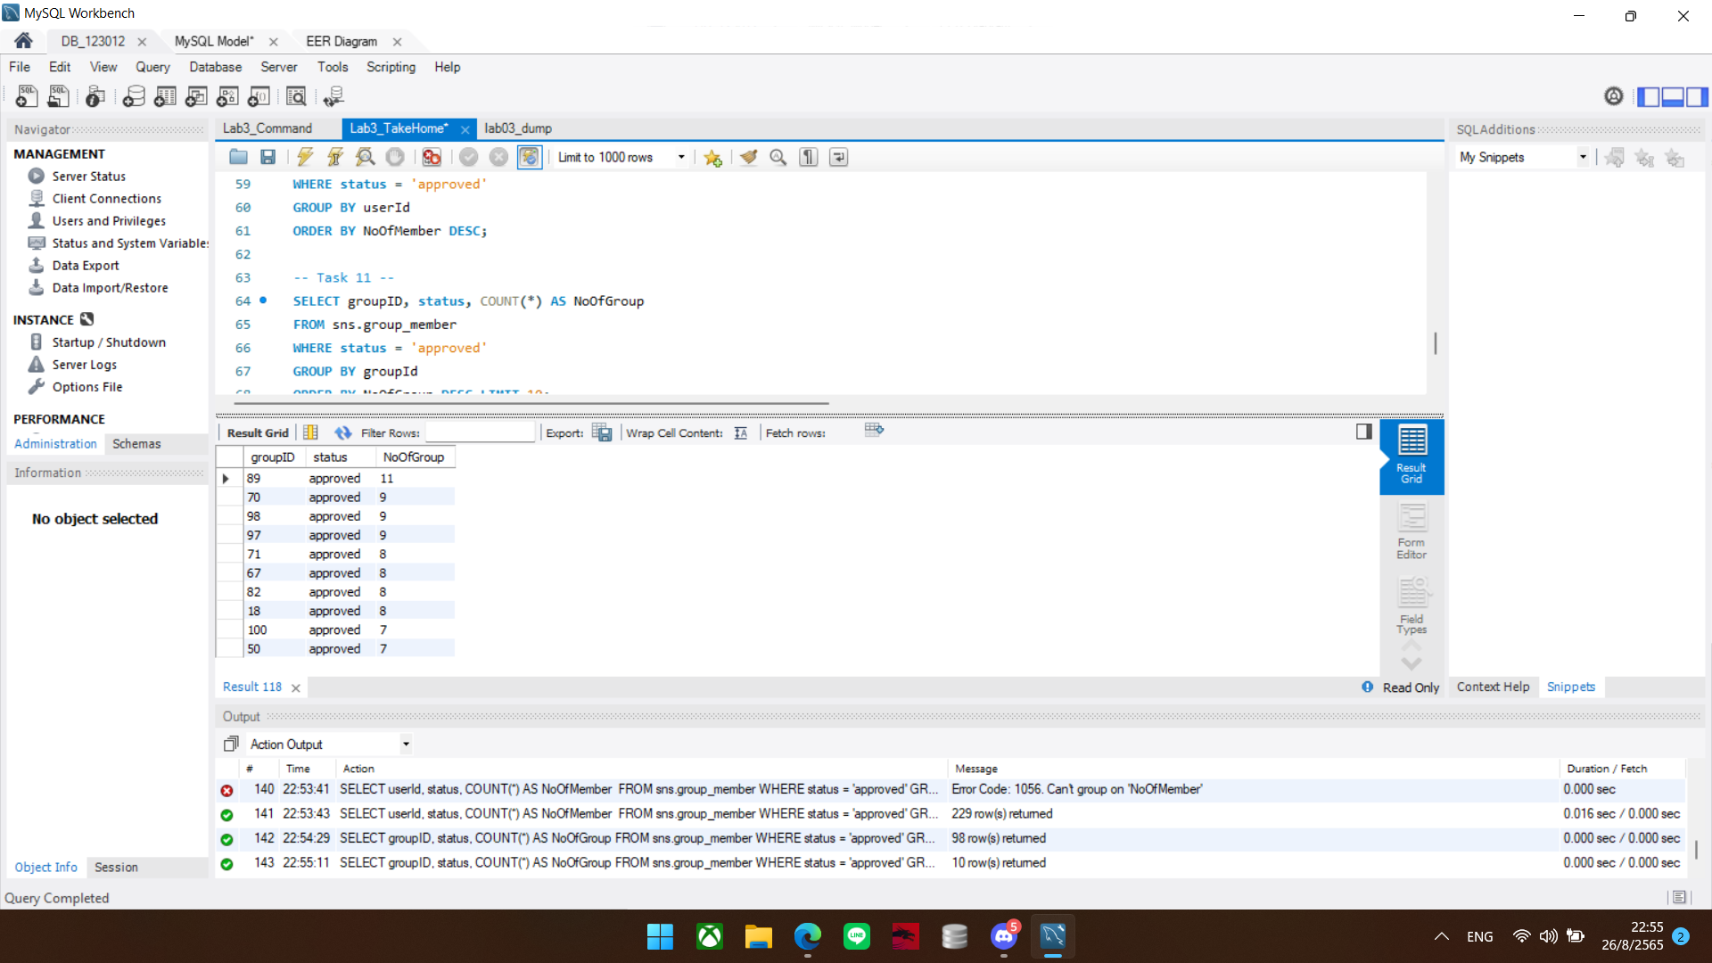

## Task 12:

What are the top 3 most trending groups for the Month of August 2022? *(Trending groups are the groups with the maximum number of posts).*

[SQL command and Snapshot]

SELECT id,title,createdAt, COUNT(*) AS MaxMember

FROM sns.group

WHERE createdAt BETWEEN '2022-08-01' AND '2022-08-31'

GROUP BY title

ORDER BY MaxMember DESC;

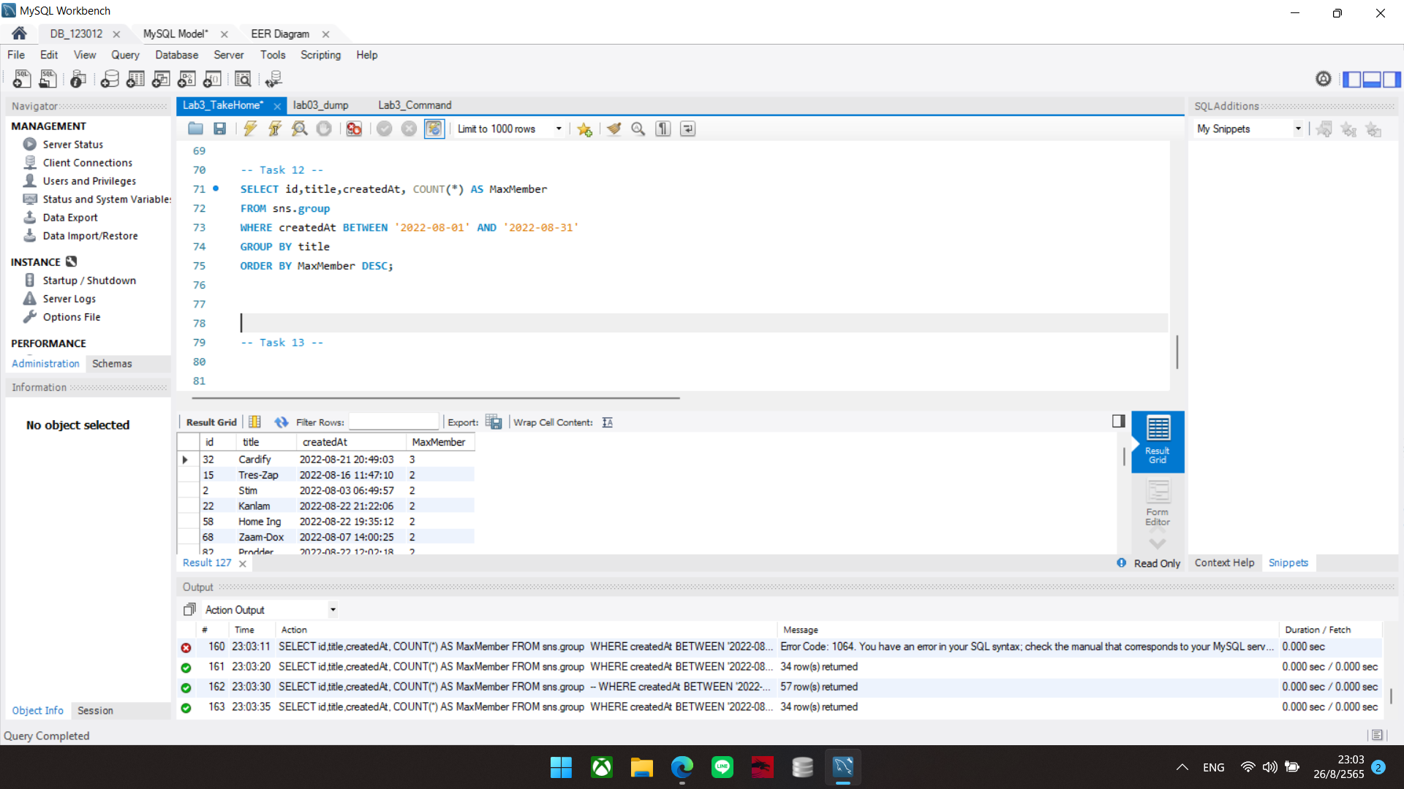

## Task 13:

If you are the administrator of this social network system, and you want to check which posts violate the terms and conditions of usage. The first violation is posting hate speech which is a post that contains the words considered banned words. Show the SQL command to filter the post having messages containing any of a word in the banned word list (you can define your own banned word dictionary of 5 words).

[SQL command and Snapshot]

SELECT *

FROM sns.user_post

WHERE message NOT LIKE '%shit%'

OR message NOT LIKE '%bad%'

OR message NOT LIKE '%hell%'

OR message NOT LIKE '%crap%'

OR message NOT LIKE '%fuck%';

